**Downloading and Installing the Cloudera VM Instructions**

**Hardware Requirements:**

(A) Quad Core Processor (VT-x or AMD-V support recommended), 64-bit;

(B) 12-16 GB RAM(16GB RAM recommended)

(C) 20 GB disk free.

**Instructions:**

Please use the following instructions to download and install the Cloudera Quickstart VM with VirutalBox before proceeding to the Getting Started with the Cloudera VM Environment

**Software Requirements and Setup Process:**

1. Download VirtualBox-7.1.6-167084-Win.exe software and cloudera-quickstart-vm-5.13.0-0-virtualbox.ova from the Google Drive link given below:
2. After downloading the required software, first start installing VirtualBox-7.1.6-167084-Win.exe.
3. After the VirtualBox software is installed, start the application, which looks like as below:

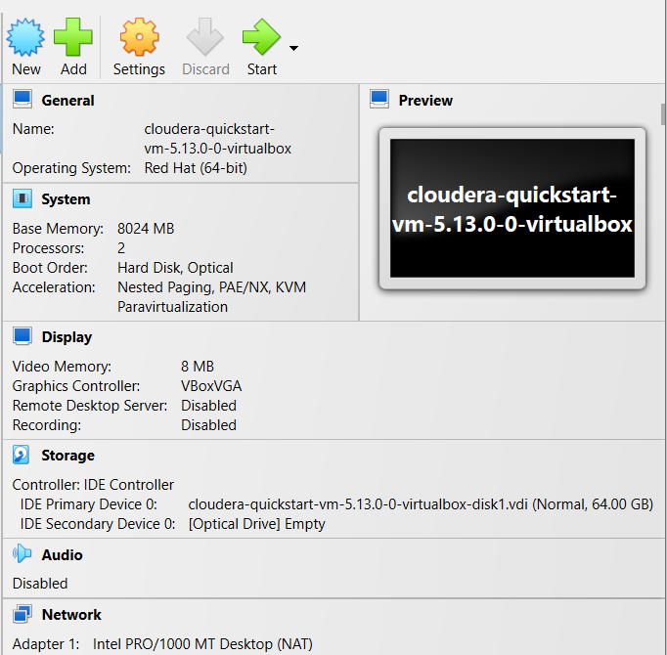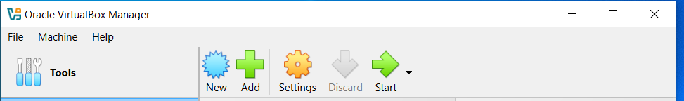

1. **Begin importing**. Import the VM by going to File -> Import Appliance

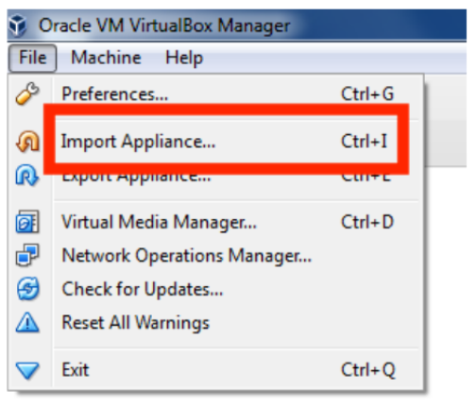

1. Click the Folder icon.

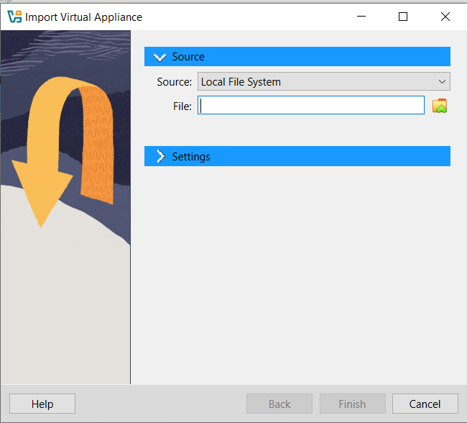

1. Select the cloudera-quickstart-vm-5.13-virtualbox.ovf from the Folder where you downloaded the VirtualBox VM and click Open

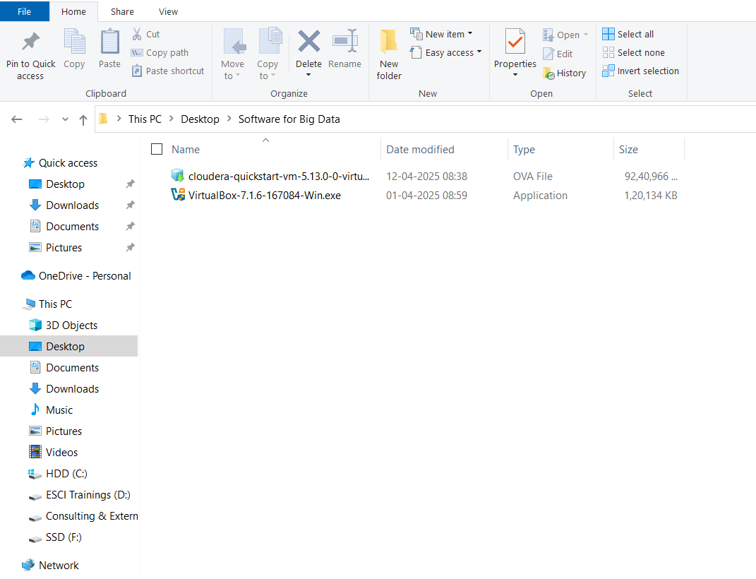

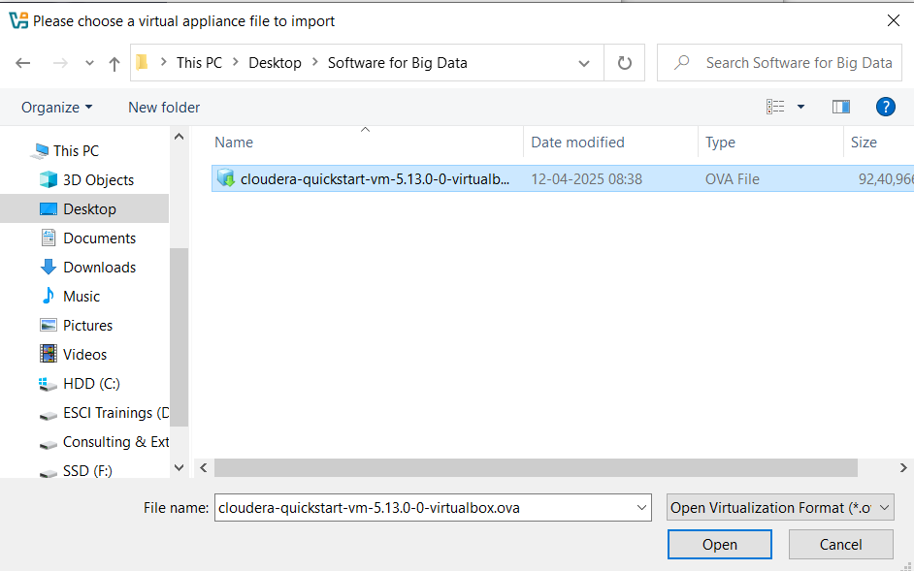

1. Click **Finish**

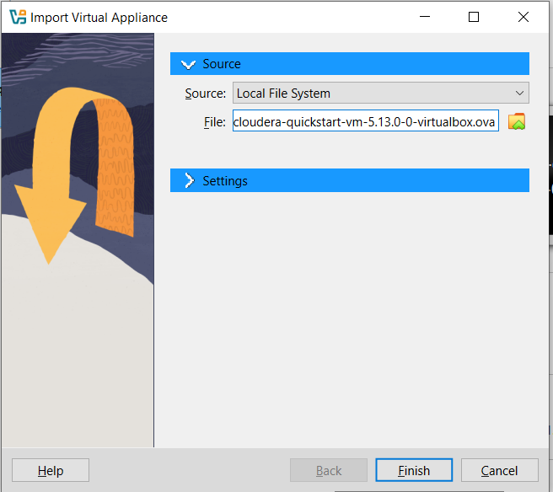

1. The virtual machine image will be imported. This can take several minutes.(Wait unitl the import process completes to 100%

Ex:

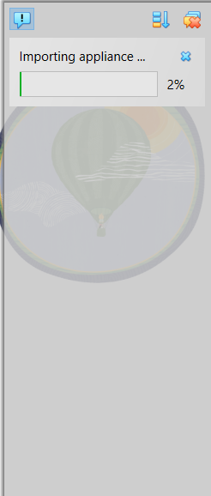

1. After importing the appliance, go to settings and perform the following:
2. Launch Cloudera VM. When the importing is finished, the quickstart-vm-5.4.2-0 VM will appear on the left in the VirtualBox window. Select it and click the Start button to launch the VM.
3. Cloudera VM booting. It will take several minutes for the Virtual Machine to start. The booting process takes a long time since many Hadoop tools are started.

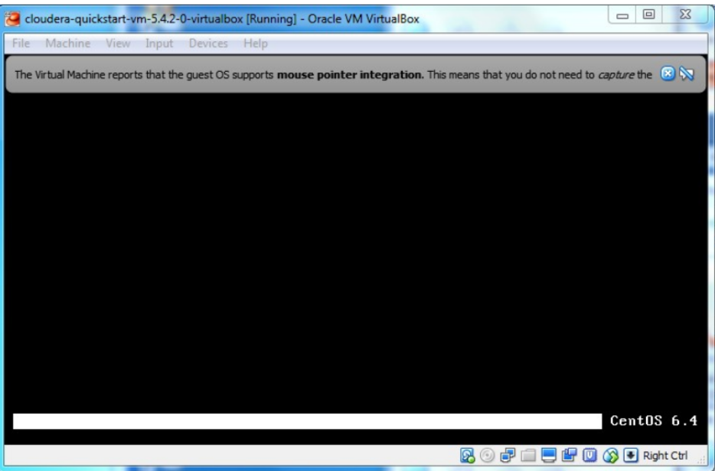

1. The Cloudera VM desktop. Once the booting process is complete, the desktop will appear with a browser.

